Information System Design Sessional

**Traffic Control System**

Group No: 4

Student Id: 1005099

1005105

1005110

1005112

1005114

**Use Case Design**

A use case specifies the behavior of a system or a part of a system and is a description of a set of sequence of actions, including variants that a system performs to yield an observable result of value to an actor.

Use case diagrams are one of the five diagrams in the Unified Modeling Language for modeling the dynamic aspects of systems. It is important for visualizing, specifying and documenting the behavior of an element. They make systems, subsystems, and classes approachable and under stable by presenting an outside view of how those elements may be used in context.

We have categorized our “Traffic Control System” into three subsystems. They are as follows:

* Optimal Route Subsystem
* Complaint Filed By Users Subsystem
* Case filing by traffic police for violation of traffic rules subsystem.

Each subsystem is divided into some use cases. In this chapter we will try to have a brief overview of the subsystems, their use cases, use case diagrams, use case narratives etc.

1. 1 Optimal Route System

The users face problem while travelling as they get stuck in traffic jam which kills their valuable time and they cannot reach their desired place in time. If the users get traffic update whenever they want, they can avoid this traffic jam by choosing the least congested route and enjoy travelling.

By this “optimal route system” user can get help from our system by getting current road situation. Our system needs two inputs from the users; their source and destination place. Mass people do the query while our data provider updates the traffic volume. So from the traffic volume users can find their desired route through which they should travel.

Use Case Glossary

|  |  |  |
| --- | --- | --- |
| Use-Case Name | Description | Participant actors and Roles |
| Route Query | Give input of the source & destination place | MP(Mass People) do the query |
| Show Route | Optimal route is suggested | DP (Data Provider) updates traffic volume;  MP see the suggested route |

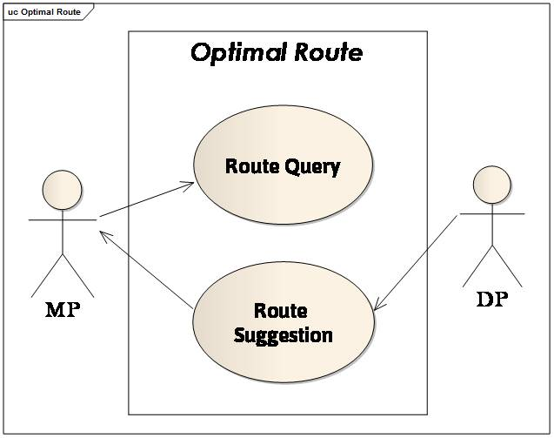Fig 1: Use case diagram for optimal route suggestion

* + 1. Route Query

Our “optimal route suggestion subsystem” includes this use case through which the users can ask the system about the condition of each route while they are travelling. Seeing the road’s condition, they can choose their desired route while travelling which will lessen their harassment due to never-ending traffic jam and save their time.

It’ll take the source and destination input from the user and then suggests the user routes based on:

* Shortest Time
* Shortest distance

Use-Case Narrative: Route Query

|  |  |
| --- | --- |
| **Use-Case Name** | **Define Route & Price** |
| Use-Case ID | 1.1.1 |
| Priority | High |
| Primary Actor | Mass People (MP) |
| External Receiver Actor | None |
| Description | Give input of the source & destination place |
| Trigger | By MP |

Typical Course of Events:

|  |  |
| --- | --- |
| **Actor Action** | **System Response** |
| Step 1: Fill up source & destination place and submit it online | Step 2: Source & Destination place stored in system |

Our system will ask from the user to give two inputs; the source and destination place .System will store the source and destination place.

Documentation of the Use Case (1.1.1)

Course of the Events

* Conclusion: concludes when the source & destination place is stored
* Post-Condition: Inform the user about the acceptance of his/her query.
* Implementation Issues: GUI will be provided in the webpage for the user to fill up the source & destination place.
  + 1. Route Suggestion

In this event users will get information/suggestion about route from our system. The system will provide two suggestions according to the

1. Shortest time

2. Shortest path issue.

Use-Case Narrative: Route Suggestion

|  |  |
| --- | --- |
| **Use-Case Name** | **Define Route & Price** |
| Use-Case ID | 1.1.2 |
| Priority | High |
| Primary Actor | Data Provider (DP) |
| External Receiver Actor | Mass People (MP) |
| Description | Optimal route is suggested |
| Trigger | None |

Typical Course of Events

|  |  |
| --- | --- |
| **Actor Action** | **System Response** |
|  | Step 1: From the saved input, the shortest optimal path is calculated depending on shortest distance between the two places |
| Step 2: DP gives the approximate traffic volume | Step 3: Traffic volume is updated for every route |
|  | Step 4: The minimum time optimal path is calculated depending on traffic volume of every route |
|  | Step 5: Both Optimal route dependent on distance & time is made ready |
| Step 6: MP sees the suggested optimal route |  |

Documentation of the Use Case (1.1.2)

Course of the Events

* Conclusion: concludes when the optimal routes are shown to users
* Post-Condition: Optimal routes are suggested
* Implementation Issues: System suggests optimal route based on shortest distance & minimum time

**2.1 Complaint Filed By Users**

In this subsystem user can file complaints regardless of the fact that where they are and complaint filed will be sent to the authority for proper action. Complaint can be filed by one vehicle driver against another, pedestrian against vehicle, user against CNG. Complaints will be sent to DMP office. DMP authority will take decision and actions will be performed by traffic police, police or by DMP authority by itself. Let’s take a look to the use case table given below.

|  |  |
| --- | --- |
| **Use Case Name** | **Actor** |
| Complaint filing | Complainer(vehicle driver, pedestrian, user) |
| View complain | DMP office, traffic authority, users. |
| Decision making | DMP office |
| Action Phase | DMP office, Traffic police, police |

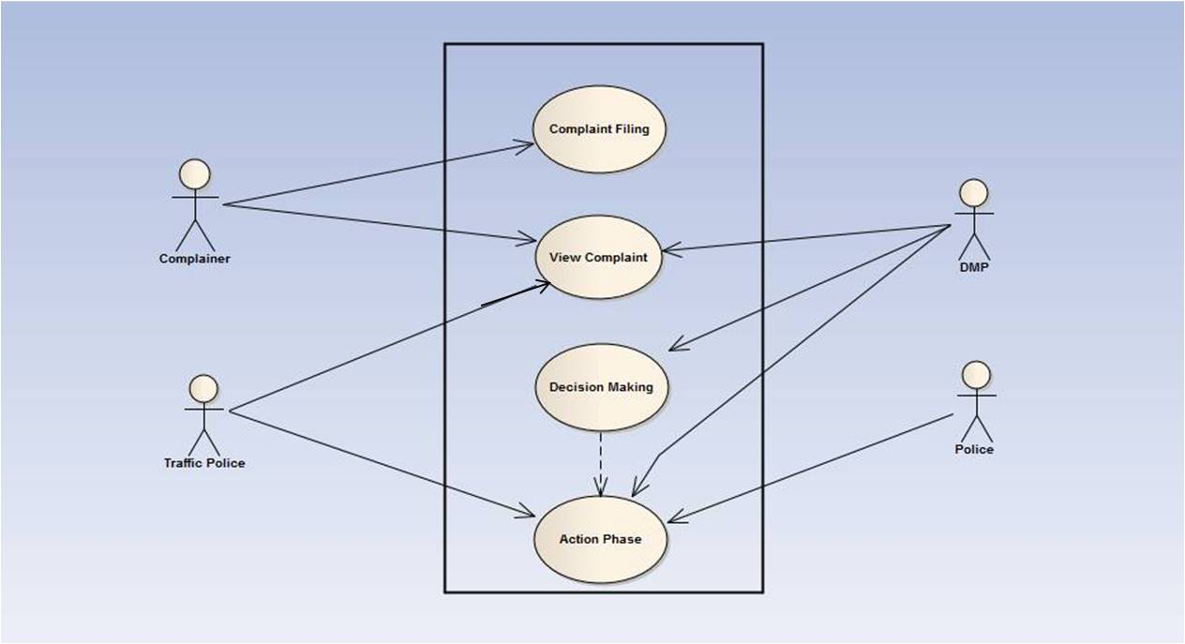 Fig 2 : use case diagram for complaint filed by users

2.1.1 Complaint filing by users

In this section, we will mainly focus on the typical course of events such as actor action and system response of our system.

**Use Case Narrative**

|  |  |
| --- | --- |
| Use case name | Complaint filing by user |
| Actor | Vehicle driver, pedestrian ,users |
| Priority | High |
| Description | This describes an event when any User/pedestrians/owner/driver files a complaint against any other car or CNG. |
| Precondition | none |
| Trigger | none |

In this section users can file complaint. Our system will give three options for complaint filing. These options are

1. File a complaint against a vehicle driver (by some vehicle driver)
2. File a complaint against vehicle (by some pedestrian)
3. File a complaint against CNG (by user)

Typical Course of Events:

|  |  |
| --- | --- |
| Actor Action | System Response |
| Step 1: Actor must go to the complaint file section (actor can go this section by using mobile message service/ by using web | Step 2: System will provide desired options |
| Step 3: actor files a complaint |  |

Actor will go to the complaint filing system; we can use mobile short messaging service /web service for complaint filing. They don’t need to have any account; simply they will go to the section and put complaint according to the systems provided options.

2.1.2 View Complaint

In this section Traffic police, DMP authority, complainer will be able to view the complaints.In this event not every traffic police or every people of DMP office will be allowed to view the complaint; some higher authority and predefined traffic police of different zone will be allowed to view the complaints, they will have an account to view the complaints. They must log in to the account and select the option for “view complaints”.

**Use Case Narrative**

|  |  |
| --- | --- |
| Use case name | View Complaint |
| Actor | Traffic police, DMP office, complainer |
| Description | This describes an event where actors can view complaints |
| Priority | High |
| Precondition | Viewer must have an account |
| Trigger | None |

Actors need to sign up their complaint viewing account for the access to view the account. System will ask for “password”. Actor must give the password for access. In this section there will be sections for different zone complaints. So the actors will easily view the complaints which were filed for his respective zone. When someone filed a complaint system will give a “complaint number”; using this complaint number complainer can delete his complain or modify the complaint.

**Typical Course of Event:**

|  |  |
| --- | --- |
| Actor action | System response |
| Step 1: Actor needs to sign up | Step 2: System asks for authentication |
| Step 3: Actor give authentication | Step 4: System gives access |
| Step 5: Actor gives command to view complaints | Step 6: System gives link to view complaints |
| Step 6: Actors view complaints and forward the complaint in different zone (if necessary). |  |

2.1.3 Decision Making

This describes an event where authority can make a decision about taking action. DMP office will receive the complaints and higher authority will take decision for taking action, authority will update the section “Decision taken by DMP” for each respective complaint. System will save the update and forward the complaint to the proper destination for the action to be performed.

**Use Case Narrative**

|  |  |
| --- | --- |
| Use case name | Decision Making |
| Actor | DMP office |
| Description | This describes an event where authority can make a decision about taking action |
| Priority | High |
| Precondition | Seriousness of the Complaint |
| Trigger | None |

Typical course of event:

|  |  |
| --- | --- |
| Actor Action | System Response |
| Step 1: Actor needs to sign up | Step 2: System asks for authentication |
| Step 3: Actor give authentication | Step 4: System gives access |
| Step 5: Actor gives command to view complaints | Step 6: System gives link to view complaints |
| Step 7: Actors view complaints and measure the seriousness of the matter |  |
| Step 8: Actor updates information regarding action and requests to save | Step 9: System save the request |

2.1.3 Action Phase

In this phase according to the DMP authority decision actions will be performed by DMP office itself, Traffic police, and police. Actors will sign into the account and go the section “Decision made by DMP”. According to the decision actors will take necessary actions and update the section “Action performed “.

**Use Case Narrative**

|  |  |
| --- | --- |
| Use case name | Action Phase |
| Actor | DMP office, Traffic Police, Police |
| Description | This describes an event where action is taken by the order of authority. |
| Priority | High |
| Precondition | Investigation |
| Trigger | None |

Typical Course of Events:

|  |  |
| --- | --- |
| Actor Action | System response |
| Step 1: Actor needs to sign up | Step 2: System asks for authentication |
| Step 3: Actor give authentication | Step 4: System gives access |
| Step 5: Actor sees necessary updates regarding any complaint |  |
| Step 6: Actors take necessary actions as he is told |  |
| Step 7: Actor updates information regarding action and requests to save | Step 8: System will save the request |

**3.1 Case filing against violation of rules**

In this subsystem, DMP will file a case against people who violate rules. General people, traffic police and DMP will be able to view the list of the people violating rules.

|  |  |
| --- | --- |
| **Use Case Name** | **Actor** |
| Case filing | DMP |
| Show list | DMP, traffic police, users |

 Fig: use case diagram for case filing

**3.1.1 Case filing**

In this section, DMP authority will be able to file case against the people who violate rules on the road.In this event not every traffic police or every people of DMP office will be allowed, only some higher authority and predefined traffic police of different zone will be allowed to file case. They will have an account to file a case. System will ask for “password”. Actor must give the password for access. Then they must log in to the account and select the option for "File Case".

**Use Case Narrative**

|  |  |
| --- | --- |
| Use case name | Case filing |
| Actor | DMP |
| Description | This describes an event where DMP can file case against a violent user |
| Priority | High |
| Precondition | Actor must have an account |
| Trigger | None |

In this section, DMP can file case against a violating user. In our system, there is a feature of car and driver profiling.DMP will file a case using this profile.

Typical Course of Events**:**

|  |  |
| --- | --- |
| Actor Action | System Response |
| Step 1: Actor needs to sign up | Step 2: System asks for authentication |
| Step 3: Actor gives authentication | Step 4: System gives access |
| Step 5: Actor files a case against the driver for violating traffic rules |  |
| Step 6: Actor updates information regarding action and requests to save | Step 7: System will save it |

**3.1.2 Show list**

In this section Traffic police, DMP authority, traffic police and general people will be able to view the list.They have to select the option for “view list”.

**Use Case Narrative**

|  |  |
| --- | --- |
| Use case name | View List |
| Actor | Traffic police, DMP , common users |
| Description | This describes an event where actors can view the list of the people who violate rules |
| Priority | High |
| Precondition | None |
| Trigger | None |

**Typical Course of Event:**

|  |  |
| --- | --- |
| Actor action | System response |
| Step 1: Actor gives command to view list of the people who violate rules. | Step 2: System gives link for checking the list |
| Step 3: Actor views list |  |